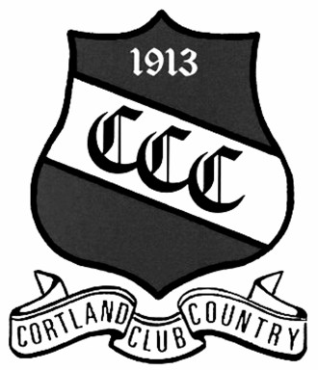
Cortland Country Club
Membership Application 2022

Name:___________________________ DOB:__/__/__ Phone: (___)___________ Mobile: (___)_____________

Address:___________________________________________City/State/Zip:___________________________

Email:_________________________________ Employer/Occupation: _________________________________

Additional family/significant others living at above address who will be active members.

Name Relationship DOB PHONE EMAIL

Membership Classification Applying For:

Family Golf Classifications | Single Golf  Classifications | Social Membership Classifications | Other Golf  Classifications
Junior Family  Associate Family  Adult Family  Senior | Junior Single  Associate Single  Adult Single | Clubhouse Social | Non-Resident  Temporary  Student  Collegiate  Limited Play

Signature:_______________________________ Application Date:___________________________

Were you referred by a current member? __________ Member Name:__________________________

Official Use
Presented to BOG:_________ Approved:_________Welcome Packet Sent:_______ Member Number__________

